Task 2 on vpc

*Create one VPC,with 1 one public subnet and 1 private subnet.*

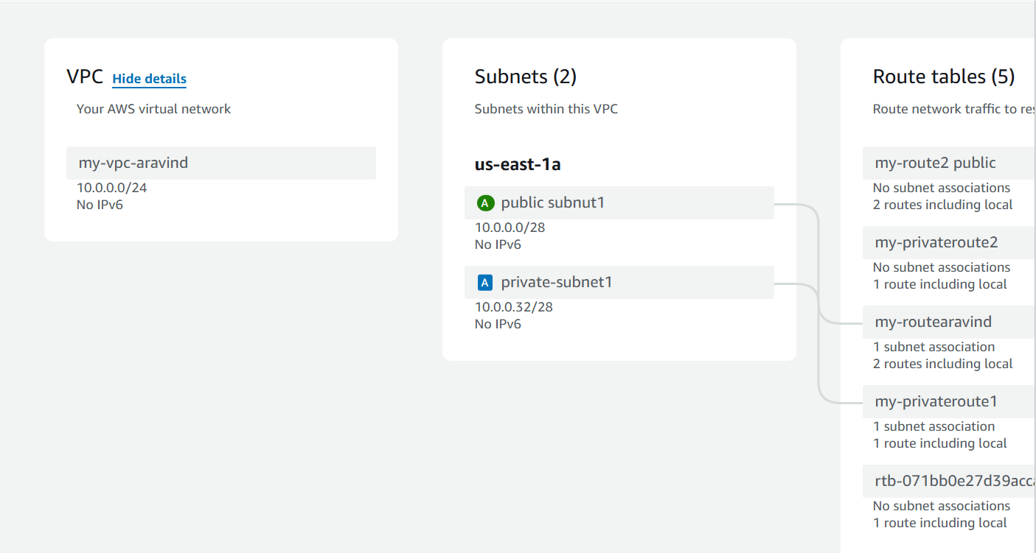

***Enable VPC peering for cross region.***

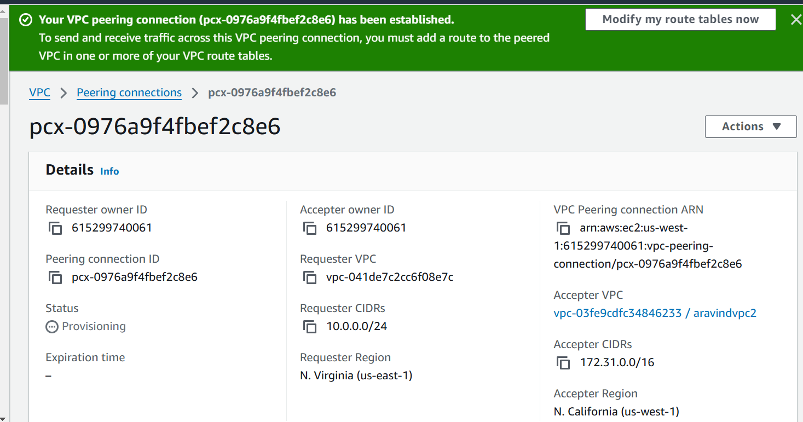

*Setup VPC Transist gateway*.

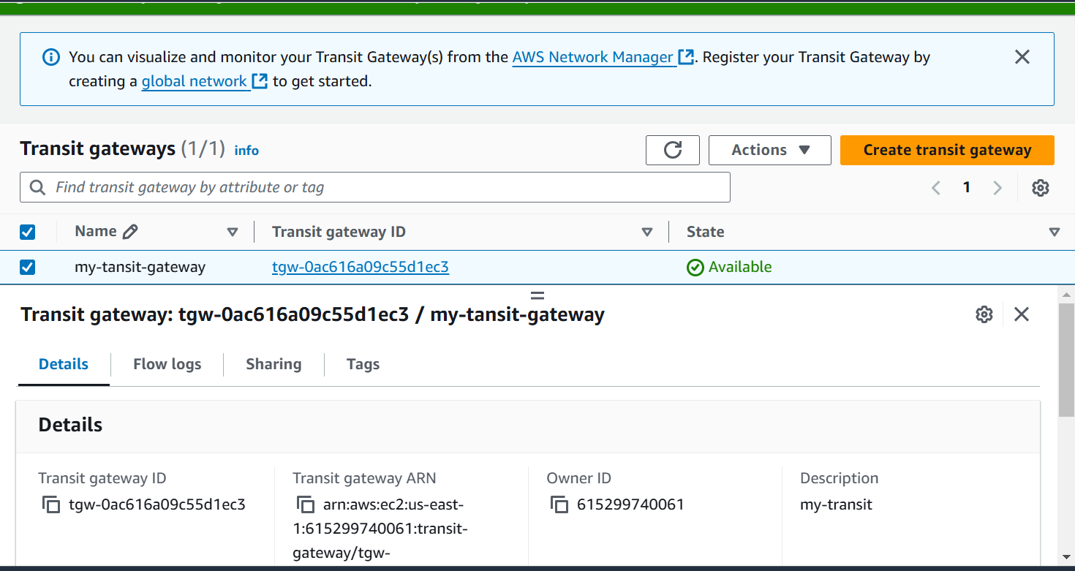

*Setup VPC End Point.*

